**DB2 Fixpack Upgrade –**

1. **Login to** [**Ansible Tower**](https://ansible-tower.ocp1.sr1.ag1.sp.ibm.local/#/templates?template_search=page_size:20;order_by:name;type:workflow_job_template,job_template)**.**

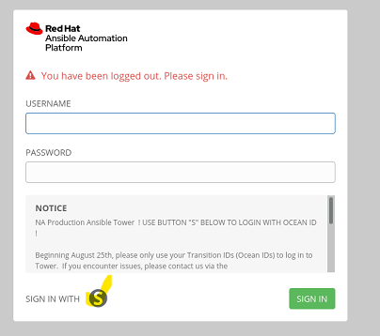

1. **Select Templates, Search for fixpack and Run Launch button.**

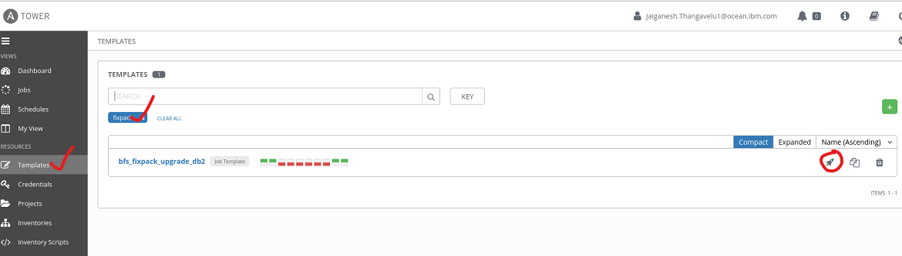

1. **Fill the Survey form carefully and submit.**

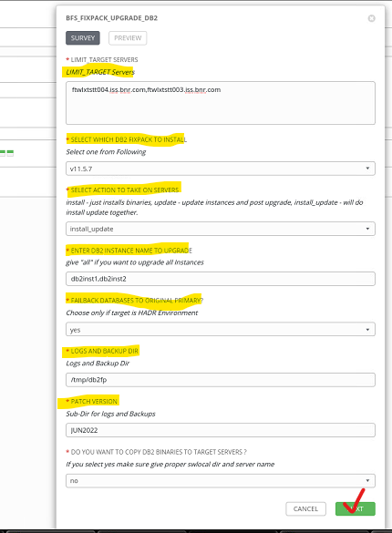

**Survey option in detail:**

1. **LIMIT_TARGET_SERVERS:** We can give number of servers here,No need to mentaion any order for primary and standby.
2. **SELECT_DB2_FIXPACK:** Select which db2 fixpack going to apply on above servers from drop down.
3. **SELECT_ACTION_ON_TARGET_SERVERS:** Chose option what action we are going to perform on target servers / instance.  
   *Avaliable options:*install_update – will install db2 fixpack and update db2 instances  
   install – Install only (Instance will not be stopped, I will just run installFixpack on new path. During installation doamin will be stopped for tsamp upgrade.  
   update – will run update only (instance will be restarted)  
   force_update –will update the db2 instances without checking any roles.( (instance will be restarted)
4. **ENTER_DB2_INSTANCE:** Enter db2 instance to apply fixpack.   
   *Avaliable options:*   
   all – for all instance in the target servers.  
   db2inst1 – for one instance.  
   db2inst1,db2inst2,db2inst3 – for multiple instances.
5. **FAILBACK_AFTER_UPGRADE:** Only for HADR Environment filp to yes or no.  
   yes – will failback databases to original primary after upgrade.  
   no –will keep databases on original principal standby after upgrade. *Default - no*
6. **LOGS_BACKUPS_DIR & PATCH_VERSION:** All backups and logs will be stored under “logsdir/patchversion” this directory. Backups and logs will be stored for each instance on their respective directory. There will be one main log created for each run “/tmp/db2fp/JUN2022/db2fixpack-$(hostname -s).log” We can see all updates in this log. *Default - /tmp/db2fp/JUN2022*
7. **COPY_BINARIES:** We have option to copy binaries before install. Make sure we have used correct source path and correct controller server when we flip this to yes. *Defautl – no.*
8. **Validate all variables and Launch.**

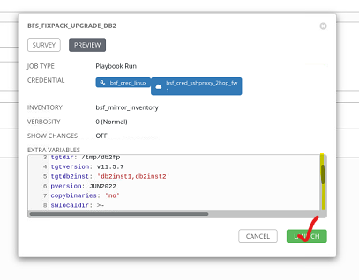

Tip: Please validate all variables before LAUNCH

1. **Playbook will start on the target servers and will perform following tasks.**
   1. Prepare target fixpack version based on user select <db2fp version>( using db2v1***.yml vars files)
   2. Pre Validate user inputs and db2 prereqchecks etc.
      1. Remove any special characters on each shell script. (local action).
      2. Copy comman functions to use for all scripts.
      3. Validate binaries exist or not (if option was “install / install_update”)
      4. Run “db2prereqcheck -i -s -l” (Fails if we not met all prereqs)
      5. Checks for new installation path empty or not.
      6. Checks for instance current db2 version and selected db2 version / fp.
      7. Prepare list of instances valid for current user inputs.
      8. Finally mark this step as completed by creating a file “/tmp/ prevalidate.complete”
   3. Display Information about which instanes valid for this fp and which or not.
   4. Prepare target server create directories, Copy binaries, Copy scripts.
   5. Start – Install Only (If option was install)
      1. Run Prebackups.
      2. Run installFixpack on new installation Directory. (no downtime) (domain will be stopped duting installation)
   6. Prepare Execution workflow based on HADR Roles.
      1. Run check_hadr_roles.sh script.
      2. Get – Cureent server roles based on HADR Roles.
   7. Standard or Auxilary Standby upgrade. (If HADR role is STANDARD or (STANDBY and REMOTE_CATCHUP))
      1. Run Prebackups
      2. Run Stopdb2
      3. Run installFixpack (this will be skipped if we select action as “update”)
      4. Run iUpdate
      5. Run Startdb2 and Runbinds and db2updv
      6. Run PostUpgradebackups
   8. Principal Standby upgrade. (If HADR role is (STANDBY and PEER))
      1. Run step “g”
      2. Run Failover databases
      3. Send signal to Primary Server (Creates a file(/tmp/standby.complete) in Primary server)
   9. Primary Server Upgrade (If HADR role is (STANDBY and PEER)) and signal from Standby
      1. Read Signal from Standby
      2. Run step “g”
      3. Failback databases (if failback set to yes)
   10. Exit for mixed HADR Roles.
       1. If HADR roles are mixed like standby for 1 database and primary for other databases script will exit without doing anything, we have to flip databases manullay to make all dbs are either standby or primary on one instance.
   11. Diplay db2level and license information after upgrade.
   12. Try’s to upgrade tsamp if they are mixed tsamp versions. And display’s output.
   13. Validate db2 and HADR TSA.

Once all done we will see screen like above. We can download and save log for feture reference.

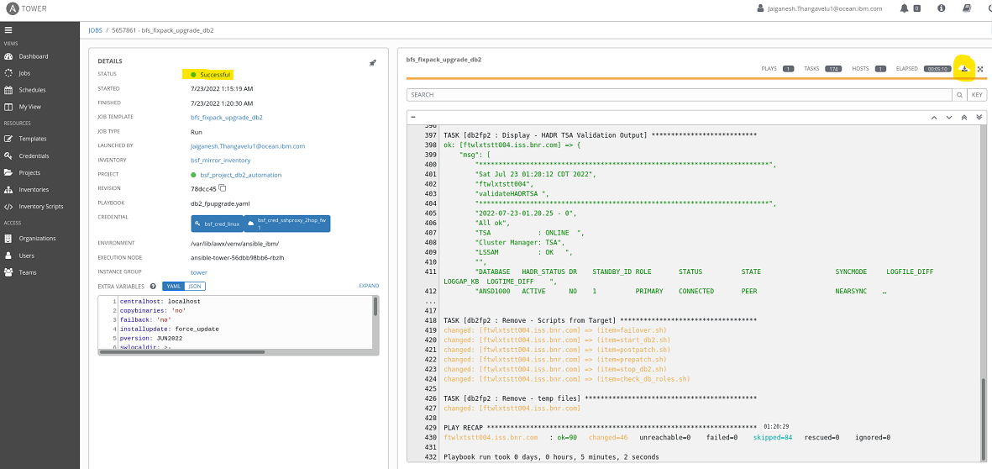

If any task failed we will see screen something like below.

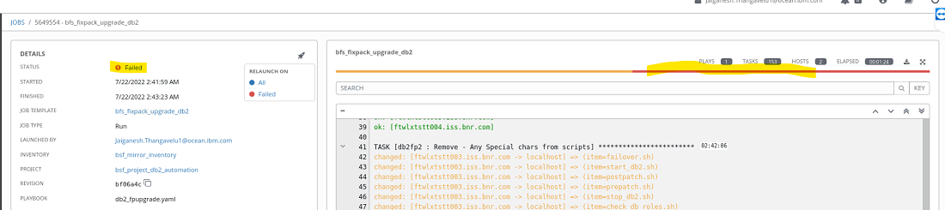

1. **Troubleshooting:**
   1. Mostly all errors/information will be displayed in Tower screen it self.
   2. If Playbook failed in between at any point, Start looking out the logs created on logs path. We can see all loggin information in “/tmp/db2fp/JUN2022/db2fixpack-$(hostname -s).log”
   3. If we want to debug more, we have instance level logs in each directory with instance name.
   4. Once we are sure we found the issue and fixed we can restart playbook, It will resume from where it failed.

